# UML Diagrams:

## USE CASE DIAGRAM :

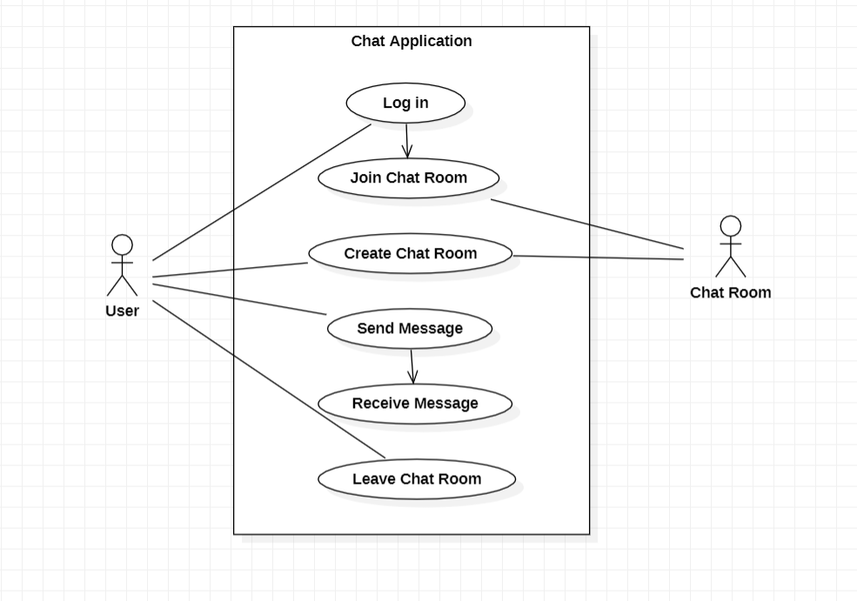

## CLASS DIAGRAM:-

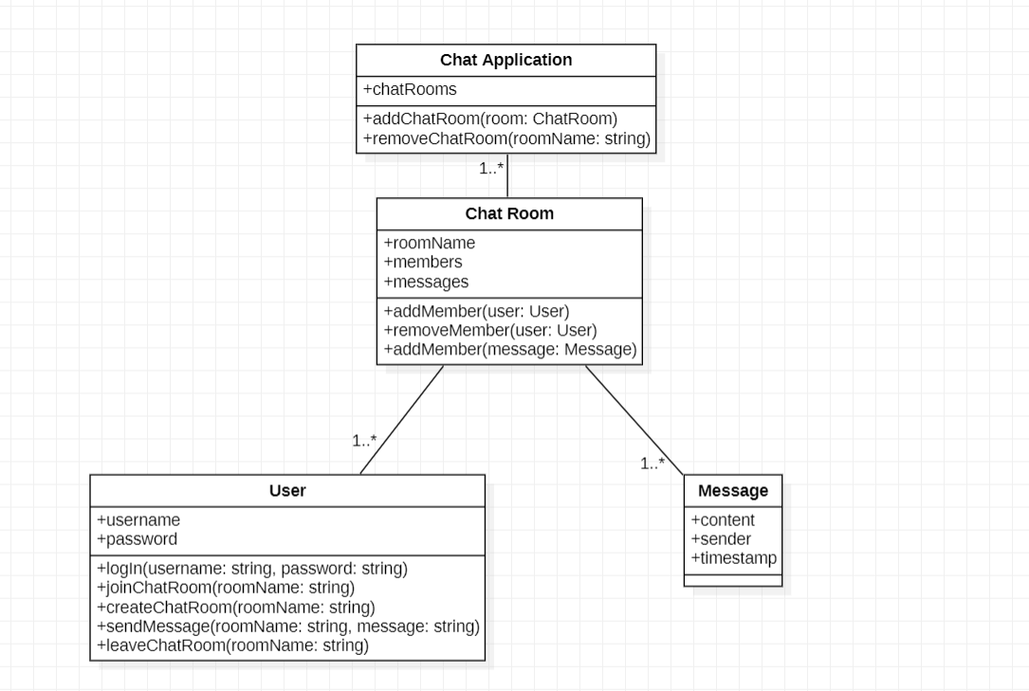

## SEQUENCE DIAGRAM :

